**The Academic Compass: A Smarter Way to Advise Students**

In an era where university curricula are becoming more complex and student populations more diverse, traditional academic advising often falls short. A study by Shadi Atalla, Mohammad Daradkeh, Amjad Gawanmeh, Hatim Khalil, Wathiq Mansoor, Sami Miniaoui, and Yassine Himeur introduces a sophisticated framework—an **academic compass**—that leverages technology to automate and personalize guidance. By merging machine learning and network analysis, this new system predicts academic performance, optimizes course planning, and helps students stay on track for a timely graduation.

At its core, the system transforms a university's course catalog into a **Course Prerequisite Network (CPN)**. Think of it as a detailed map where each course is a point and the prerequisites are the pathways connecting them. This unique perspective allows the system to identify "critical courses", those whose failure could delay graduation, by analyzing specific metrics like node degree, betweenness centrality, and deferment factors. This insight, combined with predictive performance models, provides advisors with strategic advice: which courses a student should tackle next, what electives align with their strengths, and how to accelerate their path to graduation without compromising their performance.

**The Architecture: A Three-Part Engine for Success**

The system's innovative design is built on three interconnected layers:

* **The Data Layer:** This serves as the system’s foundation, integrating a wide range of information, from student transcripts and enrollment records to demographics. It meticulously cleans and organizes this data, creating a reliable base for all subsequent analysis.
* **The Recommendation Layer:** This is the analytical powerhouse. The process follows a rigorous pipeline: data collection, preprocessing, feature engineering, and feature selection before the ML-based modeling begins. Using a suite of machine learning algorithms, including Random Forests and Bayesian Belief Networks, it predicts student grades, projects semester GPAs, and even forecasts graduation timelines. The study also compared several other algorithms, showing how these particular models stood out. It also incorporates feedback to continuously improve its recommendations, ensuring adaptability and transparency.
* **The Application Layer:** This is the user-friendly interface that brings the system's power to life. It provides students and advisors with intuitive dashboards that visualize performance forecasts and actionable suggestions, making complex data accessible to everyone.

**The Results and the Road Ahead**

The system's potential is backed by impressive results. When tested with data from the University of Dubai, its models achieved a remarkable **86% accuracy** in predicting grades, outperforming other algorithms. The analysis also revealed that courses like “Programming in Python” are critical to student success, with success in them strongly correlating to a timely graduation. The paper also acknowledges that academic performance is influenced by more than just course difficulty, noting the importance of instructor style, student demographics, and personal circumstances.

While the study had limitations, a modest dataset and a single-institution focus, it's a powerful proof of concept. The researchers envision future work scaling the system to multiple universities and integrating real-time behavioral data to provide even more precise and personalized recommendations.

In essence, this research pioneers a new, data-driven advising paradigm, a tool where predictive modeling and curriculum analysis converge to steer students toward success with unprecedented precision and empathy.

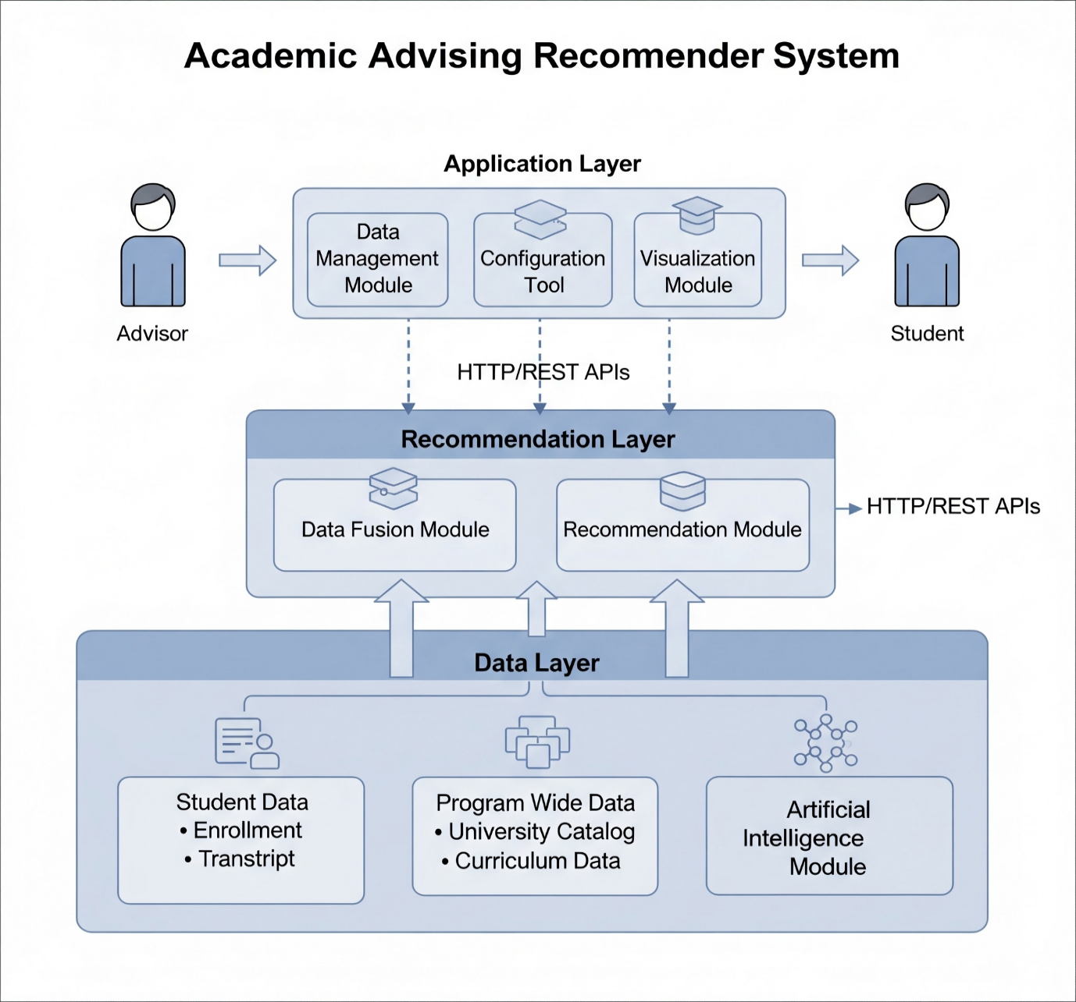

Figure